Capstone Weekly Report
Name: Peyton Hollis
Date: 4/9/26
Individual Activities
- Reading and Writing of Capstone Paper Outline
Describe what articles you have read this week, and the writing you have contribute to the capstone paper outline.

No new articles have been read this week for the project. We have completed creating a working prototype and demonstration of our complete project idea. Most of the work left in the project will be done in refining both the player tracker, key point detector, and team assigner to increase inference speed and accuracy.

Contributions to writing the capstone paper draft include distributing the capstone paper to team members, organizing our section headings, writing sections for the abstract, cv architecture comparisons, yolo model comparisons, and implementations, and providing sample images of our project running on various images.

- App Development Tutorial.
Most teams have assigned a tutorial about your demo app development. What progress have you made (this is for you, not your team). Attach the notes you have taken by learning from the tutorial if you have any. (It would be a good idea to put notes in your digital portfolio to show Professors the efforts you have put into your project.

Rijo-1/Football-Analysis-using-Computer-Vision-with-Yolov8-OpenCV: Player tracking and football analysis

A new tutorial was found that assisted our team with gaining knowledge about how key point detection, homography, and player tracking could be combined to create a 2D mapping system. Some notes include
- Using Hugging Face ViT SigLip for team assignments
  - Uses image vector embeddings to separate into two teams
- How to apply homography to create transformations from 3d to 2d map
- How key points are used to plot exactly where field dimensions are located
- How key points are used to determine player locations and map to 2d

This tutorial was useful for creating artifacts, examples, and documents for Antigravity to assist with the creation of this project. Antigravity was not capable of reasoning by itself to create solutions for this project. The creation of these examples and artifacts assisted Antigravity enough to begin to create a working project. More refinement was needed but this tutorial created a helpful base.
Team Meetings
- Have your team met this week? If yes, when and where? If not, explain.
Our team met this week in person at the Shepherdstown University Library. During this meeting we discussed where we were at with our project prototype and demonstration. We discussed that we have a working product and need to work more on refining it.
We also began to work on the capstone final paper draft. We discussed what was desired within the final paper and began to recreate and edit the previous outline.
Capstone Project Progress
- Writing
How is your capstone paper outline writing going?

We began writing out capstone paper draft yesterday. Each group member is available to dedicate work and time before the draft due date.

- Demo App Development
What progress have your team made in developing the demo app?

The full project pipeline and idea has been realized within the last two weeks. We currently have a working project. All other work that will be done will be in creating a demonstration website and fine-tuning the models for better accuracy and speed to be used within a real-time application.

Add at least 2 screen captures here.

Key point detection example
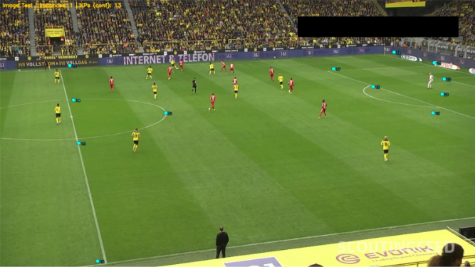
Player detection and team assignment example
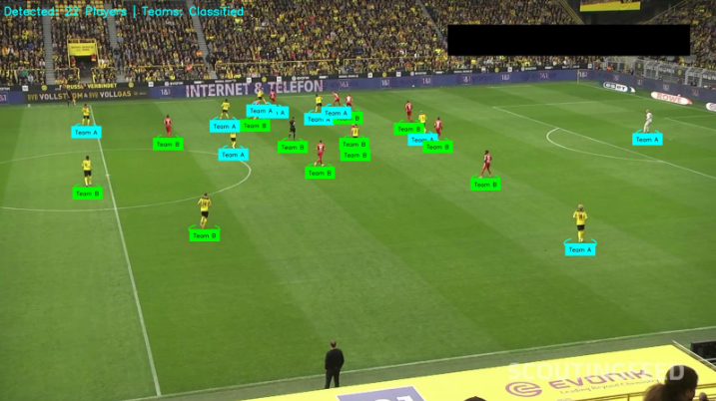
Final project output example
